- Characteristics
- Application
      - Advertisement
      - Indicators
      - Back Lights
      - Illumination

      - High-Brightness LED
      - Lens Color : RED
      - Half Angle(2θ1/2) :120°
      - Superior Weather-resistance
      - UV Resistant Epoxy

- Directivity ■Outline Dimension
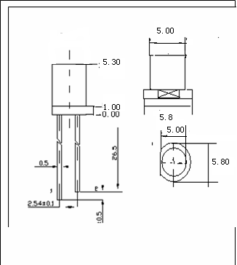

■ Electrical Optical Characteristics
Item | Symbol | Min. | Typ. | Max. | Unit | Condition
Luminous Intensity | Iv | 350 | --- | 500 | mcd | IF=20mA
Viewing Angle | 2θ1/2 | --- | 120 | --- | Deg | IF=20mA
Wave length | WLD | 620 | --- | 630 | -- | IF=20mA
Forward Voltage | VF | 1.9 | --- | 2.1 | V | IF=20mA
Reverse Current | IR | --- | --- | 5 | μA | VR=5V

  - Please Refer to CIE 1931 chromaticity diagram

- Absolute Maximum Rating
Item | Symbol | Maxabsolute | Unit
Power Dissipation | PD | 100 | mW
Peak forward current(1/10 duty cycle,0.1ms pulse width | IFP | 50 | mA
Continuous forward current | IF | 20 | mA
Derating linear from 50℃ |  | 0.4 | mA/℃
Reverse voltage | VR | 5.0 | V
Operating temperature range | Topr | -40℃ to +80℃
Storage temperature range | Tstg | -40℃ to +100℃
soldering temperature | Tsod | 260℃ for 3 Seconds
- Pulse width Max 10ms Duty ratio Max 1/10
- Optical Electrical Characteristics

